# L&T Hub: Designing & Delivering a Lesson Plan

Lesson Plan A: EAS Model Structure

Tutor: Subject/class: Duration of class: Number of students:

|  |  |  |  |  |
| --- | --- | --- | --- | --- |
| **Introduction**  *How you will introduce the topic/class.* | **Explanation**  *How you will explain the material.* | **Activity**  *How you will engage students.* | **Summary/sharing**  *How you will summarise or draw on your students’ knowledge.* | **Conclusion/feedback**  *How you will conclude the class and gather feedback from your students.* |
| *E.g. talk to your students about the main points from the lecture* | Activity 1: *Name* | | | *Gather information on what has been learnt and if your students’ perceptions have been changed.* |
| *E.g. discuss with the class the varied types of marketing that is available to small business* | *Provide the class with a list of key concepts to be researched on small business marketing. Each group will be asked to research a single topic. Each explanation of a concept will need to be supported with an example.* | *Discuss the presentation of the concepts, linking important points.* |
| Activity 2: *Name* | | |
|  |  |  |

# L&T Hub: Designing & Delivering a Lesson Plan

Lesson Plan B: General Planning Template

Tutor: Subject/class: Duration of class: Number of students:

|  |  |  |  |  |
| --- | --- | --- | --- | --- |
| **Time** | **Activity** | **Purpose** | **Assessment & SLO Links** | **Resources** |
| 5 minutes |  |  |  |  |
|  |  |  |  |  |
|  |  |  |  |  |
|  |  |  |  |  |

# L&T Hub: Designing & Delivering a Lesson Plan

Lesson Plan C: Visual Planning Template

Subject: Lesson: Date:

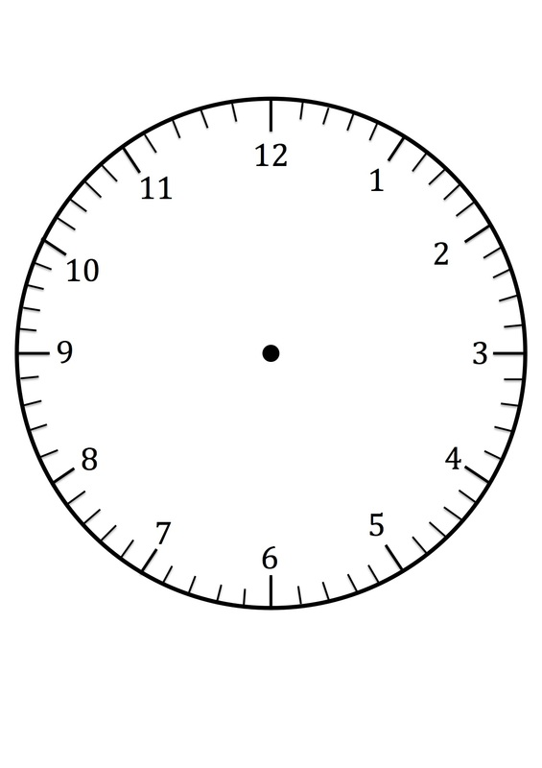

Details: